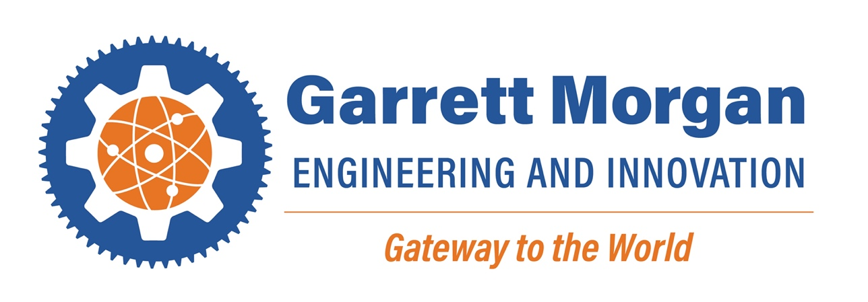

**2022-2023 Bell Schedule**

|  |
| --- |
| Period 1 8:30 AM – 9:14 AM |
|  |
| Period 2 9:17 AM – 10:01 AM |
|  |
| Period 3 10:04 AM – 10:48 AM |
| LUNCH |
| Period 4a-GMSEI LUNCH 10:51 AM – 11:11 AM |
| Period 4b- ADVISORY 11:15 AM – 11:35 AM |
| Period 4 Class 10:51 AM – 11:35 AM |
|  |
| Period 5a-GMSEI LUNCH 11:38 AM – 11:58 AM |
| Period 5b- ADVISORY 12:02 PM – 12:22 PM |
| Period 5 Class 11:38 AM – 12:22 PM |
|  |
| Period 6a-GMSEI LUNCH 12:25 PM – 12:45 PM |
| Period 6b ADVISORY 12:49 PM – 1:09 PM |
| Period 6 Class 12:25 PM – 1:09 PM |
|  |
| Period 7a-GMSEI LUNCH 1:12 PM – 1:32 PM |
| Period 7b ADVISORY 1:36 PM – 1:56 PM |
| Period 7 Class 1:12 PM – 1:56 PM |
| LUNCH |
| Period 8 1:59 PM – 2:43 PM |
| Period 9 2:46 PM – 3:30 PM |